**ADD CHILD COMPONENT TO PARENT DINAMICALLY – ANGULAR 5**

**REF:**

<http://www.advancesharp.com/blog/1214/angular-2-dynamically-add-remove-components>

<https://medium.com/front-end-hacking/dynamically-add-components-to-the-dom-with-angular-71b0cb535286>

FIRST WE DEFINE A REFERENCE ATRIBUTE IN CHILD COMPONENT TO BE LINKED TO PARENT COMPONENT ADDING IT DINAMICALLY.

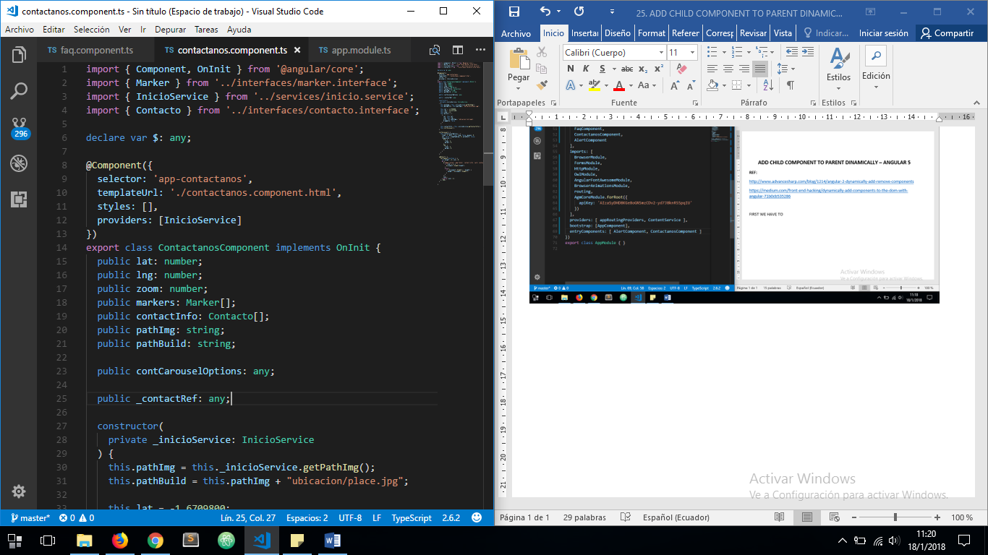

THEN WE HAVE TO DEFINE AS ***entryComponent*** THE CHILD COMPONENT ON ***app.module.ts***

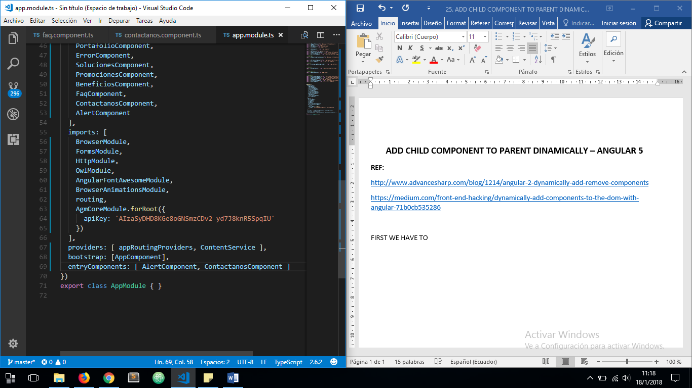

NOW, ON PARENT TEMPLATE WE HAVE A CONTENT SECTION TO BE TAKEN FROM ITS COMPONENT CLASS TO ADD THE CHILD COMPONENT PROGRAMMATICALLY

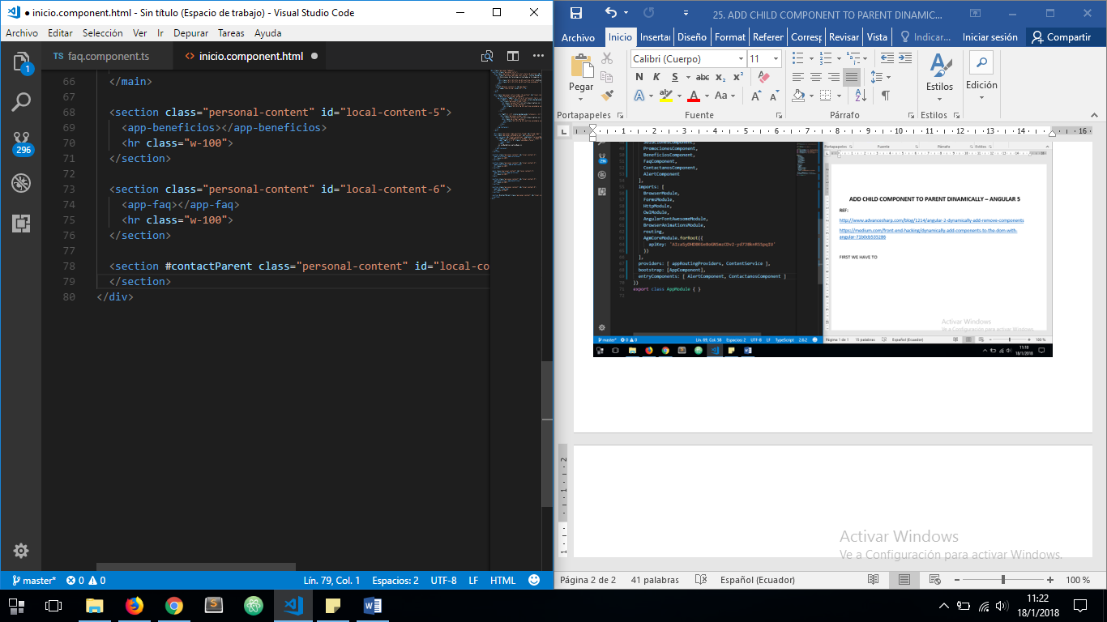

NOW DEFINE A ***@ViewChild*** ATRIBUTE TO TAKE THE PARENT CONTAINER FROM THE DOM

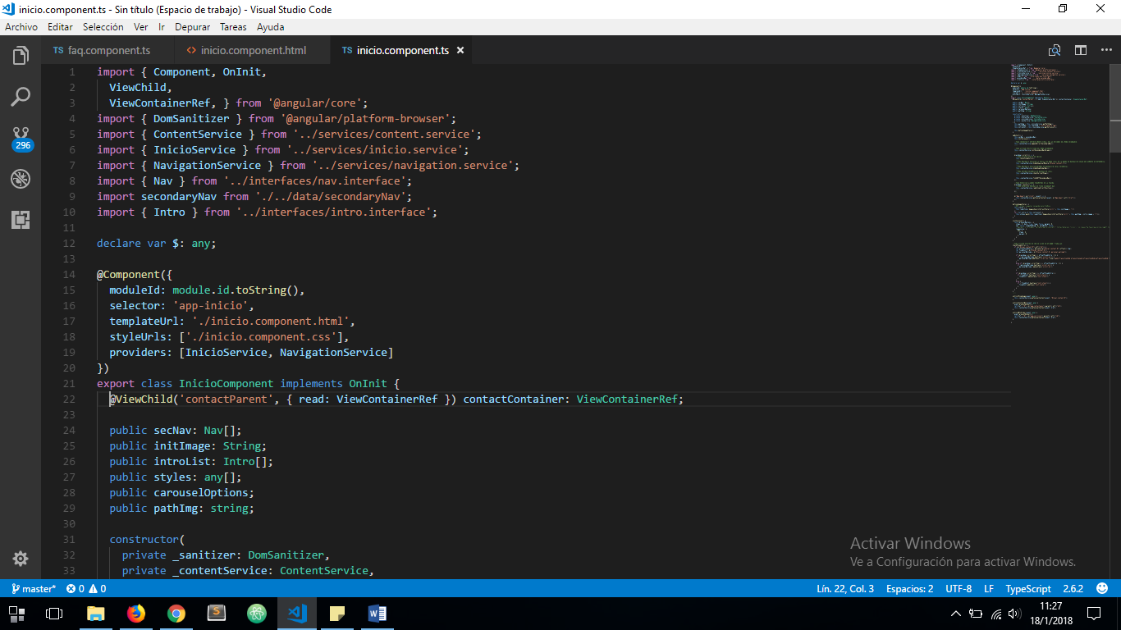

NOW IN PARENT COMPONENT CONSTRUCTOR WE ADD A NEW ATRIBUTE FROM ***@angular/core ComponentFactoryResolver*** CLASS TO HANDLE THE CHILD COMPONENT REFERENCE

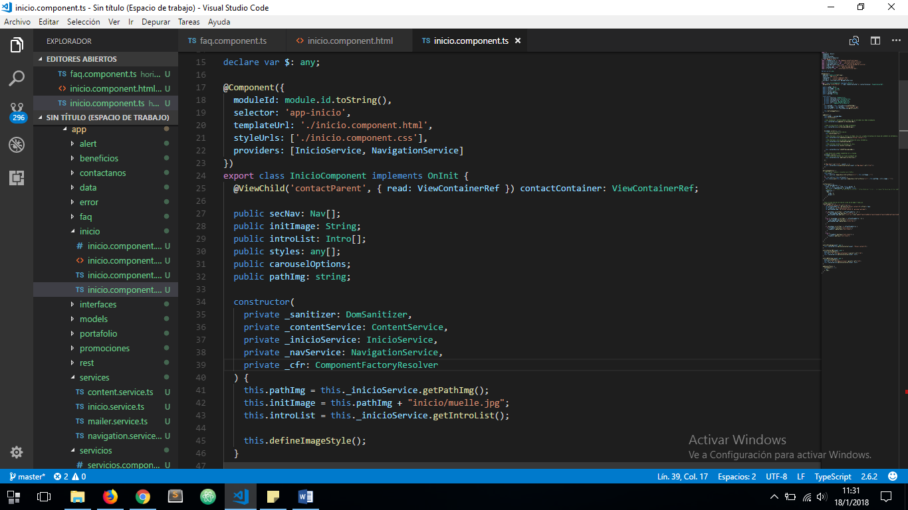

WE IMPORT THE CHILD COMPONENT INSIDE THE PARENT COMPONENT

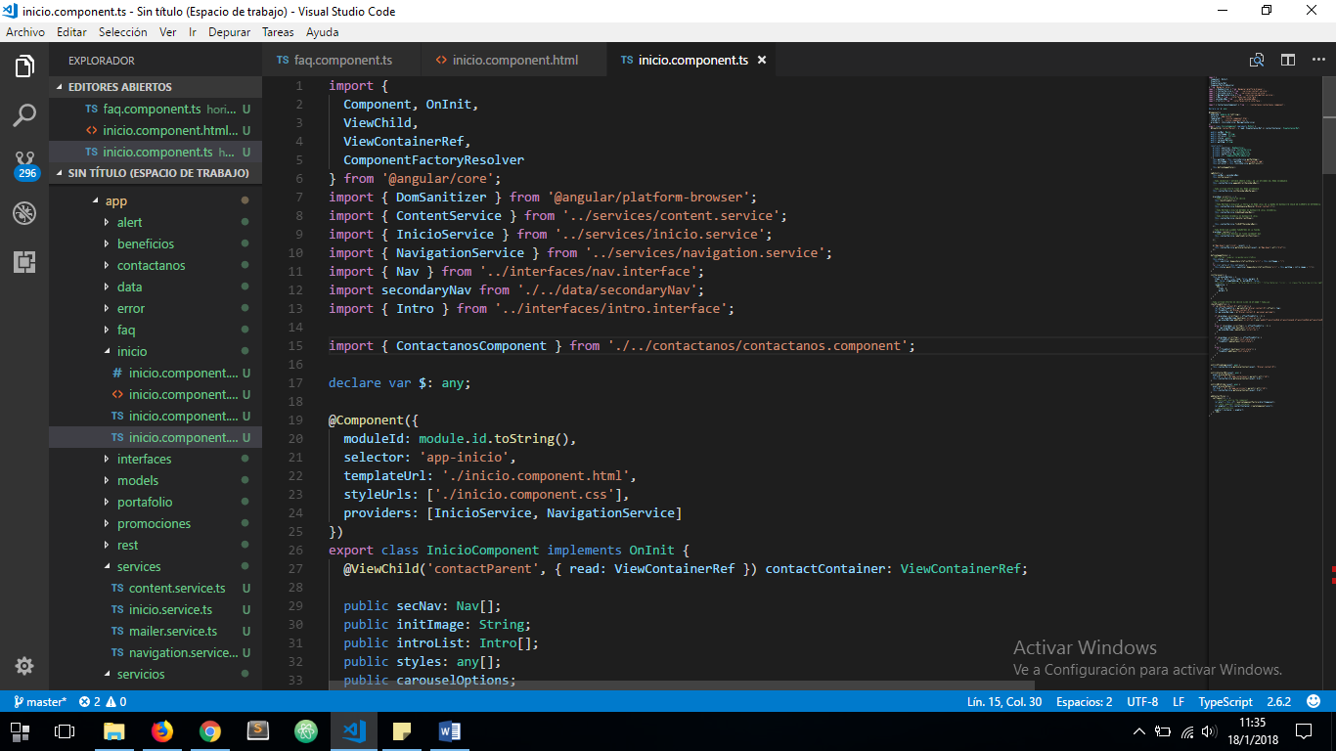

CREATE A NEW METHOD ON PARENT COMPONENT TO ADD CHILD COMPONENT ON PARENT’S TEMPLATE

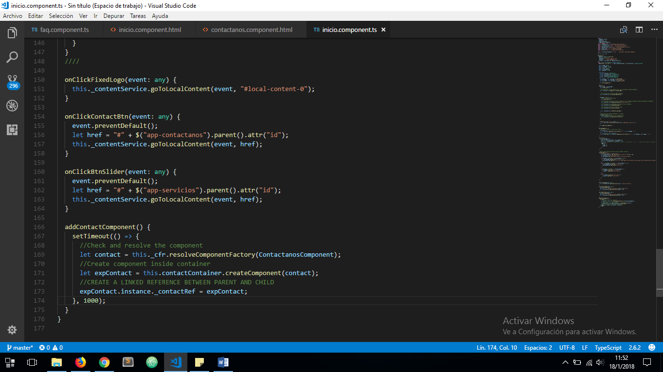

CALL ABOVE METHOD INSIDE ***ngOnInit()*.** CONTACT COMPONENT IN THIS CASE MUST BE ADDED TO THE DOM 1 SECOND AFTER THE ENTIRE DOCUMENT HAS ALREADY LOADED

AND SEE THE RESULTS:

